Hogwarts Booking System – Final version Documentation

1. Introduction
The Hogwarts Booking System is a web-based facility reservation and utilization platform. It enables students and teachers to reserve campus facilities while providing administrators with management tools. The system ensures fair access, prevents misuse, and integrates role-based access control.

2. Project Overview & Final Version
The final version (Version 5) of the system includes the following functionalities:
- Homepage as the greeting page for all users (Admins, Students, Teachers)
- Role-based login system
- Admin/Staff Dashboard with facility management
- Staff ability to block/unblock available timeslots (only unbooked slots)
- Students and Teachers can book facilities for a maximum of 3 hours daily
- Students and Teachers can cancel their bookings if required
- Admin access restricted to system management functions
Earlier in Version 4, admin were able to block ongoing bookings. Based on feedback, this feature was deemed unfavourable. In Version 5 (final), the system was updated to only allow blocking of available/unbooked timeslots, ensuring fairness for all users.

3. Pages & Key Behaviours
- Home Page: Landing page for all users.
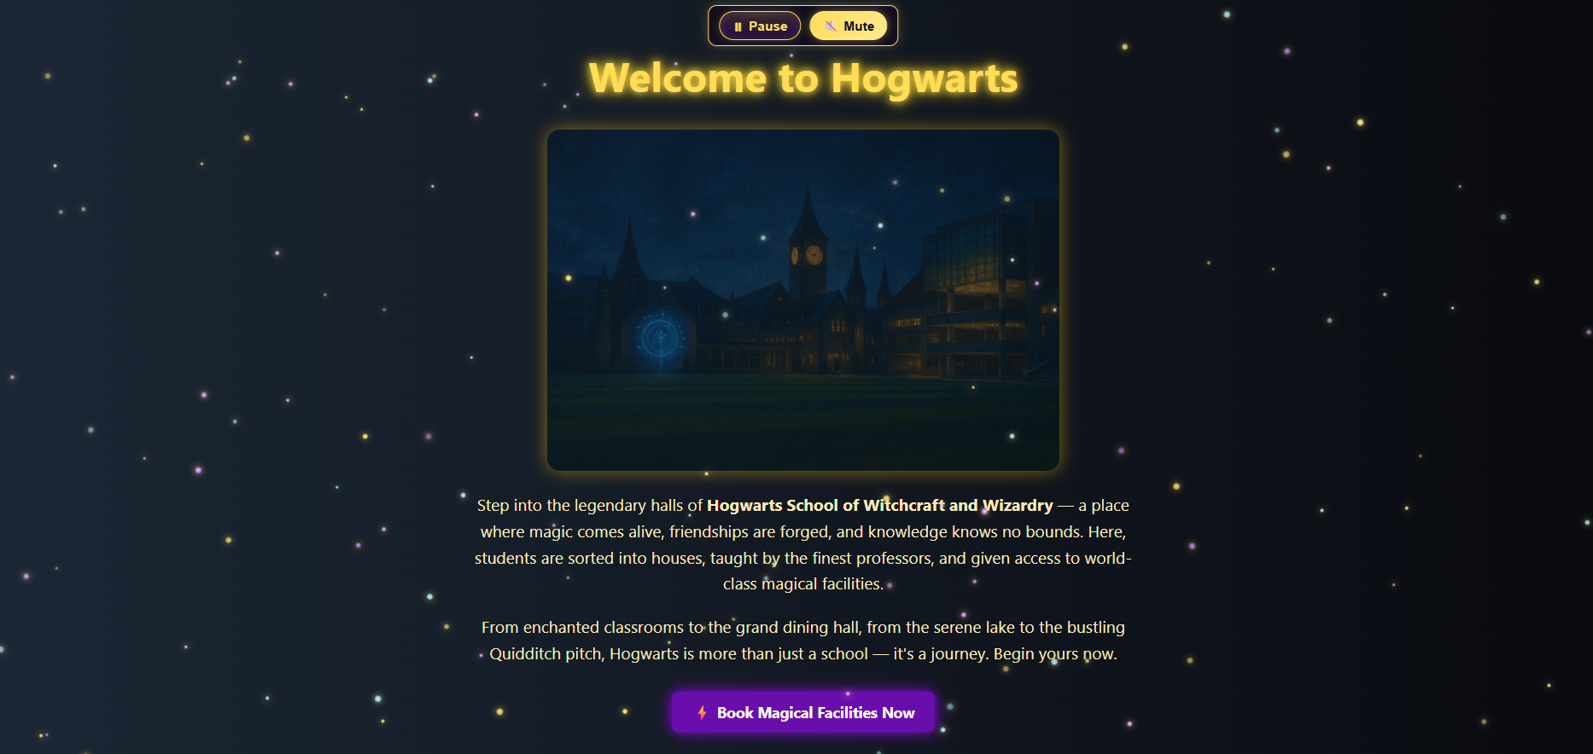
- Login Page: Role-based login for Admin, Students, Teachers.
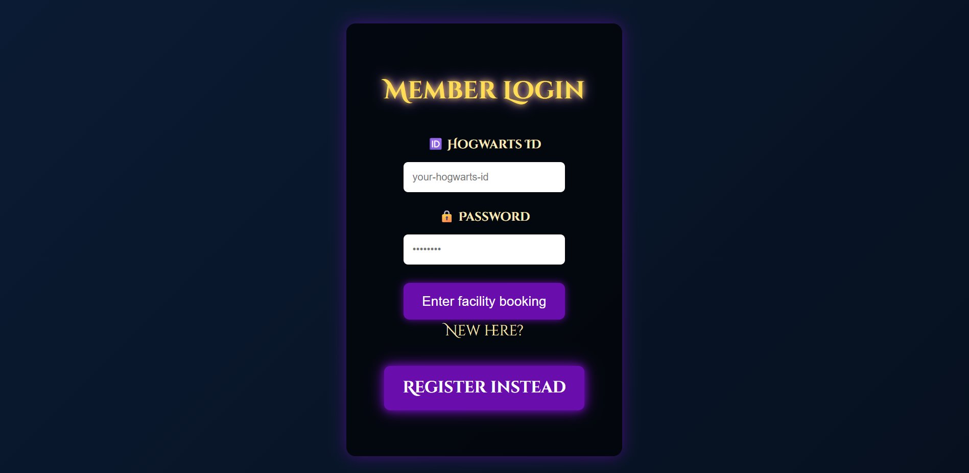

- Registration Page: User registration form with validation.
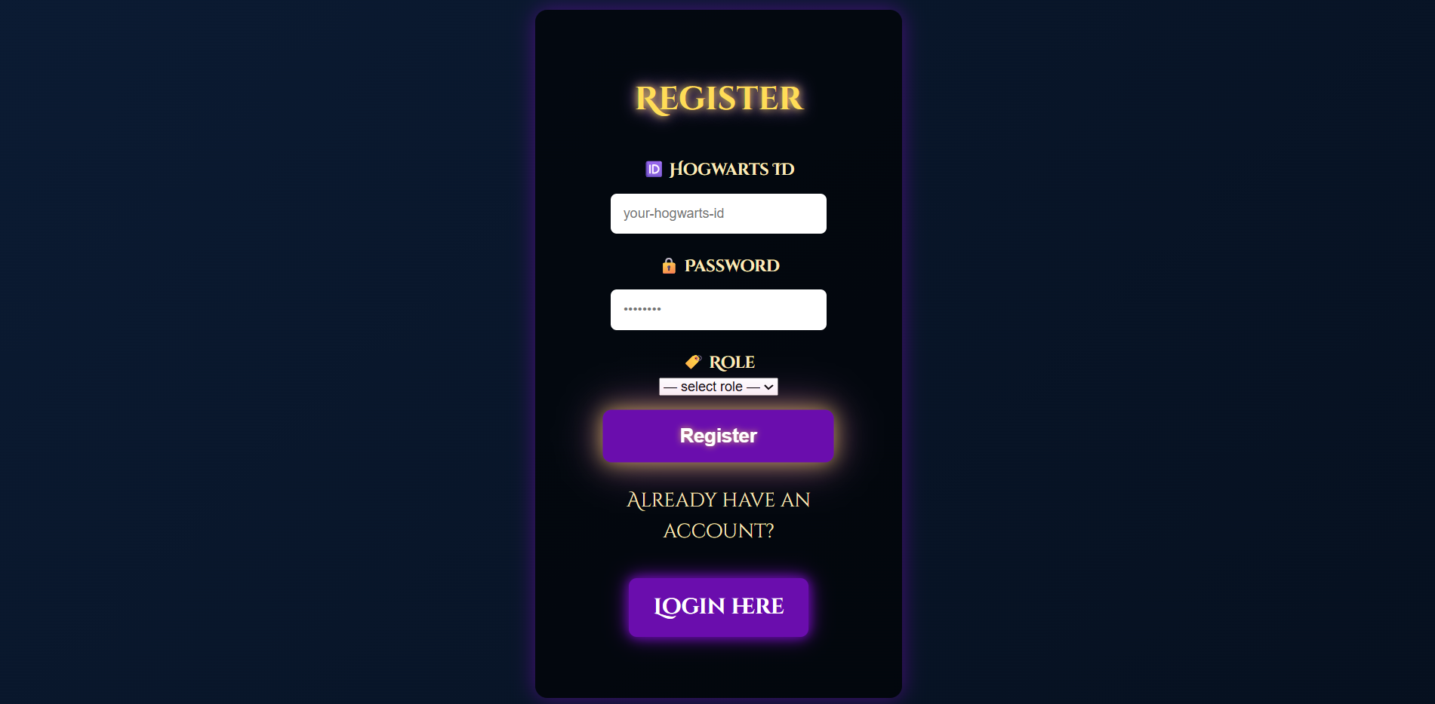

- Registration as Student or Teachers.
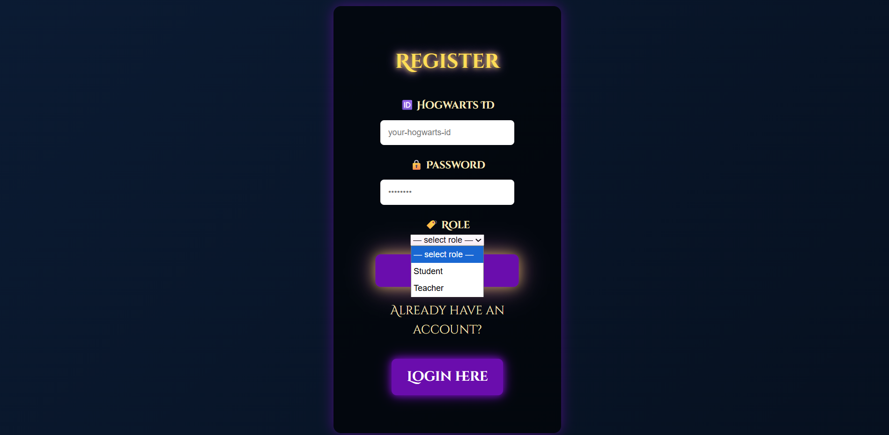
- Booking Page: Allows Students/Teachers to book facilities (max 3 hours daily).
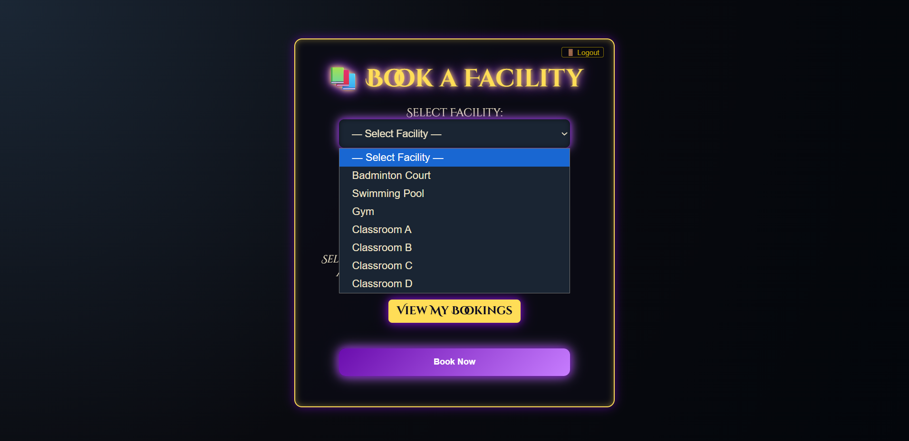
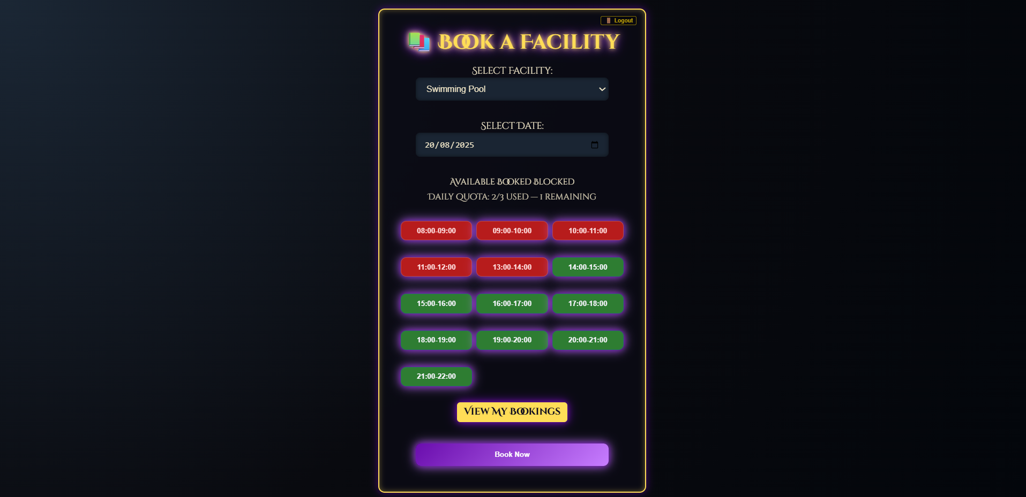

- Booking Display Page: Users can view and cancel their bookings.
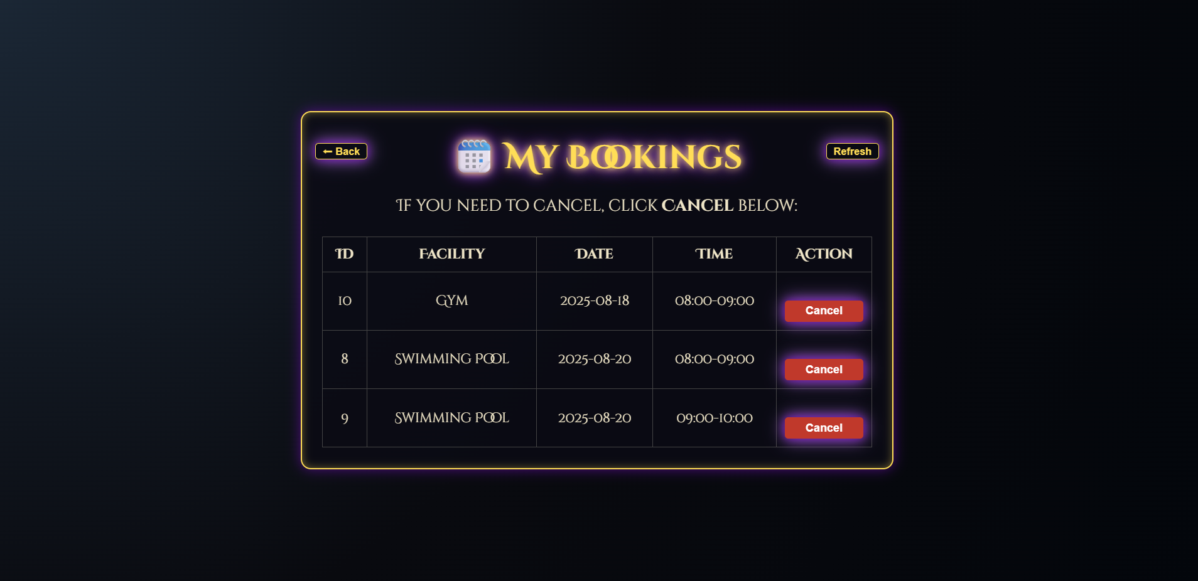

- Staff Page: View booking statistics and pie charts for facility utilization.
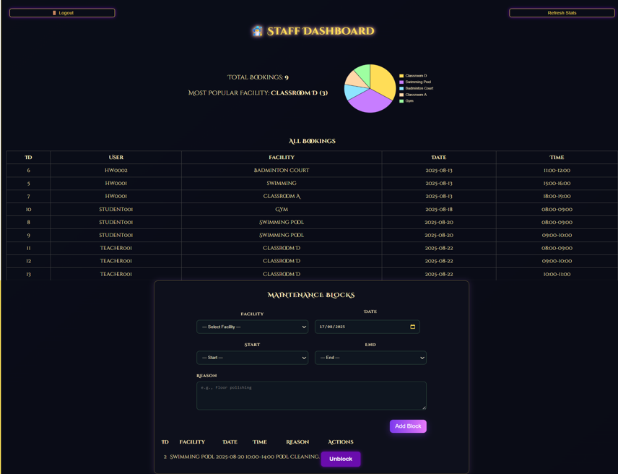
- Dashboard (Staff/Admin): Allows blocking of timeslots, management of facilities, and ensures only Admins have elevated access.
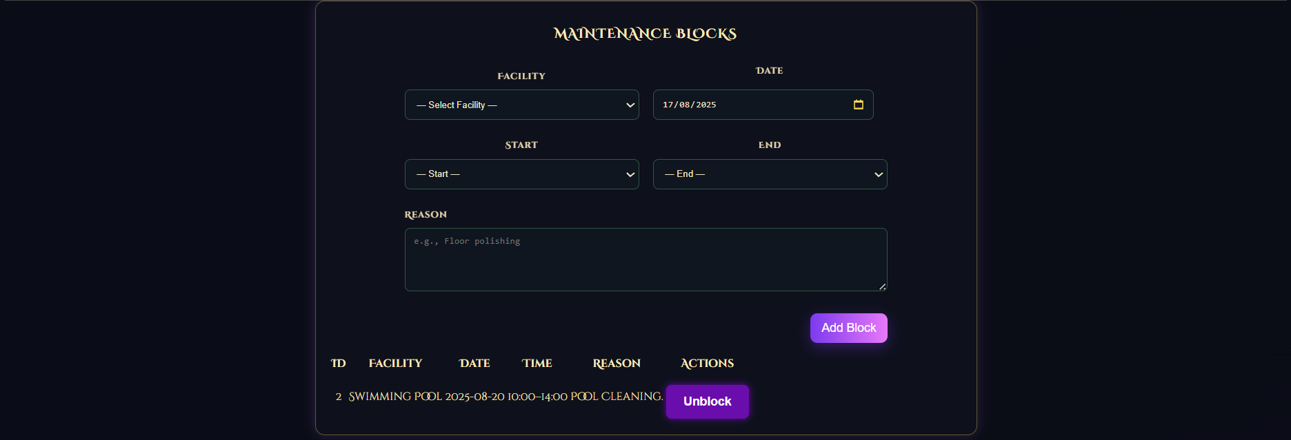

4. CSS Conventions & Highlights
- Consistent theme inspired by Hogwarts (dark magical look)
- Buttons styled with glowing/pulsing effects (Register, Logout)
- Tiny icons (Back, Refresh, Calendar) styled for usability
- Responsive layout tested for desktop, with partial mobile compatibility
- Centralized headings and form labels for alignment
- Gradients, glowing shadows, and pulsing animations to enhance user experience

5. Common Issues & Fixes
- Issue: Staff could block ongoing bookings (Version 4)
Fix: Updated logic to only allow blocking of unbooked timeslots (Version 5).
- Issue: Labels not properly aligned with input boxes
Fix: Adjusted CSS to centralize and align form labels.
- Issue: Buttons (Back, Refresh, Logout) inconsistent in design
Fix: Unified styling across all pages with CSS classes.
- Issue: Calendar icon not visible in dark theme
Fix: Updated calendar icon to gold for better contrast.

6. Future Work
- Implement full mobile responsiveness for all pages.
- Add email notification system for booking confirmations/cancellations.
- Introduce facility usage analytics with advanced filtering.
- Add two-factor authentication for Admin/Staff accounts.
- Allow recurring bookings with advanced approval workflow.

